**PRACTICAL 2**

Aim: To implement Bresenham’s algorithms for drawing a line segment between two given

end points.

Objective:

Draw a line using Bresenham&#39;s line algorithm that determines the points of an n-dimensional

raster that should be selected to form a close approximation to a straight line between two

points

Theory:

In Bresenham’s line algorithm pixel positions along the line path are obtained by determining

the pixels i.e. nearer the line path at each step.

Algorithm -

Step 1: Except the two end points of Line from User.

Step 2: Calculate the slope(m) of the required Line.

Step 3: Identify the value of slope(m).

If slope(m) is Less than 1 i.e: m &lt; 1

Calculate the constants dx, dy, 2dy, and (2dy – 2dx) and get the first value for the

decision parameter as -

p0 = 2dy − dx

Step 4: At each Xk along the line, starting at k = 0, perform the following test −

If pk &lt; 0, the next point to plot is (xk + 1, yk) and

pk+1 = pk + 2dy

else

plot (xk + 1, yk + 1)

pk+1 = pk + 2dy − 2dx

Repeat step 4 (dx - 1) times.

If slope(m) is greater than or equal to 1 i.e: m &gt;= 1

Calculate the constants dx, dy, 2dy, and (2dy – 2dx) and get the first value for the

decision parameter as -

p0 = 2dx − dy

step 5: At each Yk along the line, starting at k = 0, perform the following test −

If pk &lt; 0, the next point to plot is (xk, yk + 1) and

pk+1 = pk + 2dx

else

plot (xk + 1, yk + 1)

pk+1 = pk + 2dx − 2dy

Repeat step 5 (dy - 1) times.

Exit.

Program -#include<iostream.h>

#include<conio.h>

#include<graphics.h>

#include<dos.h>

void bsline(int x,int y,int x2,int y2)

{

int dx,dy,p;

dx=x2-x;

dy=y2-x);

p=2*(dy)-(dx);

while(x<=x2)

{

if(p<0)

{

x=x+1;

y=y;

p=p+2*(dy);

}

else

{

x=x+1;

y=y+1;

p=p+2*(dy-dx);

}

putpixel(x,y,RED);

delay(10);

}

}

void main()

{

int gd=DETECT,gm;

initgraph(&gd,&gm,"C:\\turboc3\\bgi");

int x1,x2,y1,y2;

cout<<"Enter the x1,y1,x2,y2 values: ";

cin>>x1>>y1>>x2>>y2;

bsline(x1,y1,x2,y2);

getch();

closegraph();

}

Output –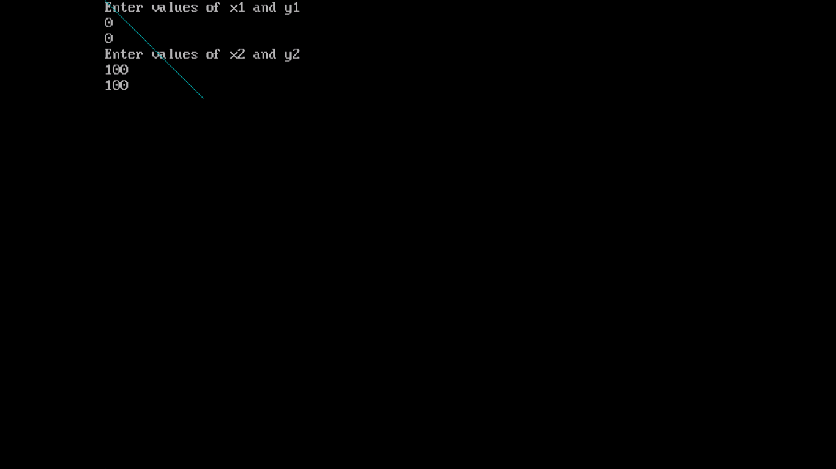

Conclusion: Comment on -

5. Pixel: It selects the pixel closest to the actual line path, resulting in an efficient and accurate line drawing on the discrete grid.

6. Equation for line: y = mx+ c

7. Need of line drawing algorithm: The algorithm's ability to use only integer arithmetic and incremental calculations makes it highly efficient, making it suitable for real-time applications and devices with limited computational resources.

8. Slow or fast: Fast